**EXPERIMENT NO. 10**

**AIM: Case Study of Linux Commands**

**RESOURCES REQUIRED:**

H/W Requirements: P-IV and above, Ram 128 MB, Printer, Internet Connection**.**

S/W Requirements:Linux Operating System.

**THEORY:**

|  |  |
| --- | --- |
| Commands | Typical Use |
| ls (list) | listing all the folders and files in current or specified directory. |
| pwd (print working directory) | Printing current working directory. |
| cd (change directory) | Changing current directory. |
| mkdir (make directory) | To create new directory (folder). |
| nano | To open existing file or creating and opening new file. |
| cat (Concatenate) | Commonly use to print content of file there are lots of different uses too. |
| rm (remove) | Deleting files. |
| rmdir (remove directory) | Deleting directory (folder). |
| echo | To insert or append into text into files. |
| sudo | To get superuser access. |
| apt | Use for upgrading, installing, listing, searching, etc apps |
| cp (copy) | Copying files from current directory to specify directory. |
| grep | To check the string content in specified files. |
| free | To get the information of all the memory. |
| lshw (list hardware) | To get information of system hardware. |
| history | History of all the commands used. |
| ping (packet internet groper) | This command is used to check the network connectivity between host and server/host. |
| hostname | Return hostname |
| ps (process state) | To get the Process state |
| mv (move) | To move files from one directory to another or renaming the files. |
| clear | To clear the terminal. |

**Conclusion:** Hence, we have successfully study and used essential Linux commands.

**Output :**

Basic use of pwd, ls, cd and mkdir:

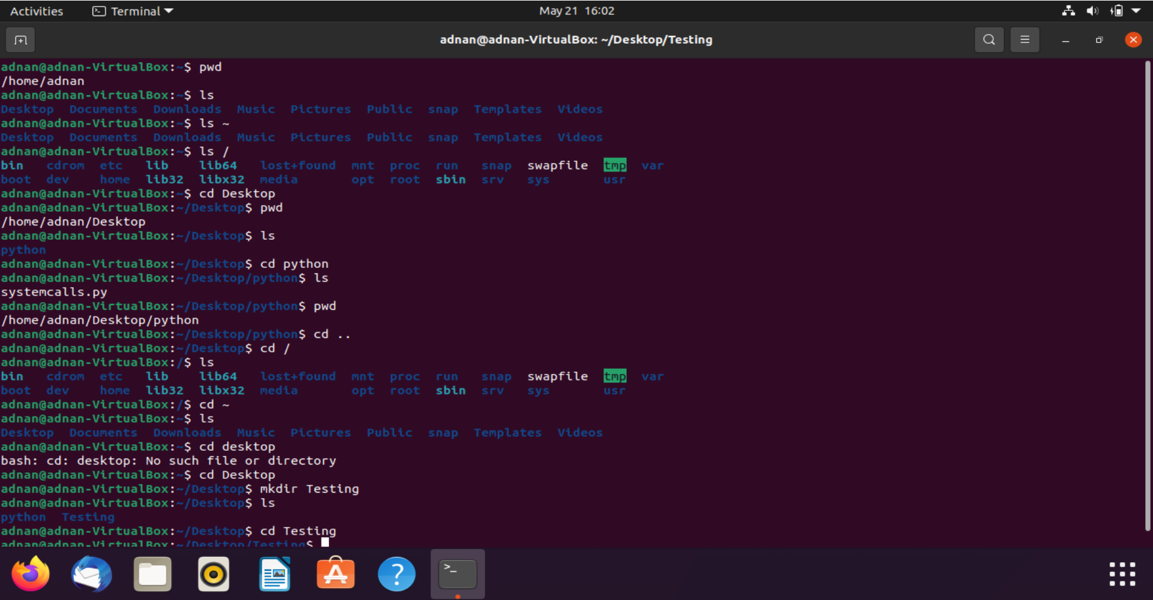

**nano command**:

Before using **nano**, Testing(directory) is empty :



Afte using **nano** to create test.py file:

Created newfile

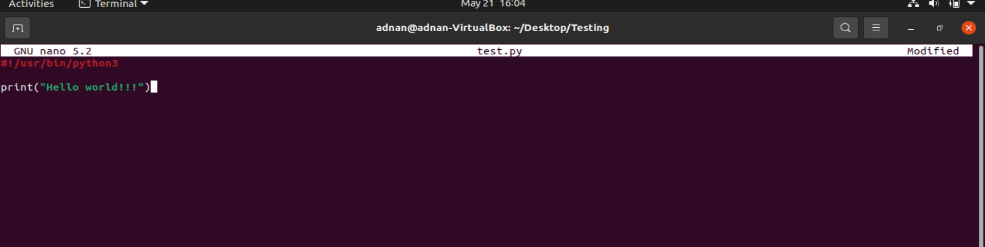

**ls command:**

Using **ls** to check if the file is created



**rm command:**

Using **rm** to remove test.py and checking if it removed successfully using **ls**:



**echo and cat command**:

Creating file mdhash256texting.txt using **nano** and appending string into the using **echo** and checking the content of file after appending using **cat:**

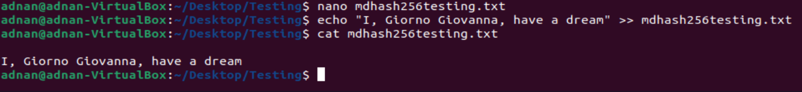

**More functionality of cat**:

Creating file1.txt and file2.txt and writing text through terminal into them using **cat** command and merging them in file3.txt using same:

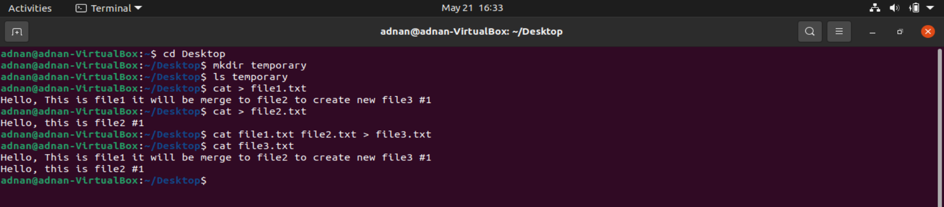

Getting CPU and OS information using **cat:**

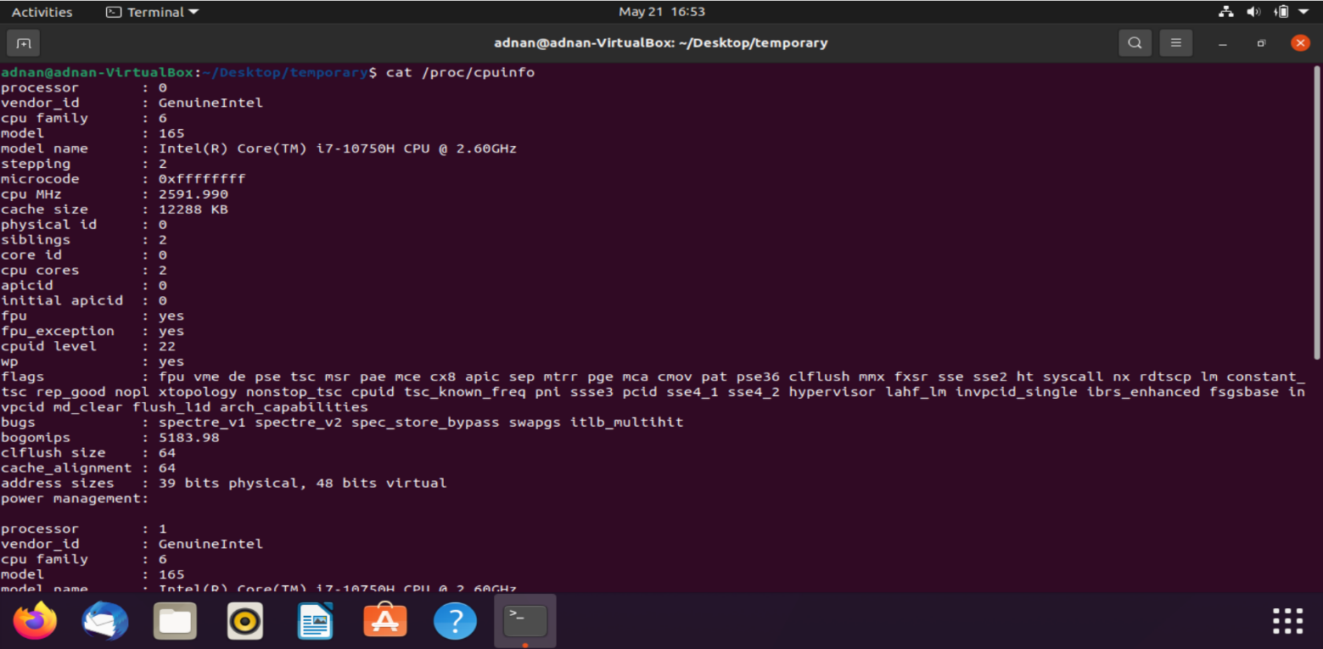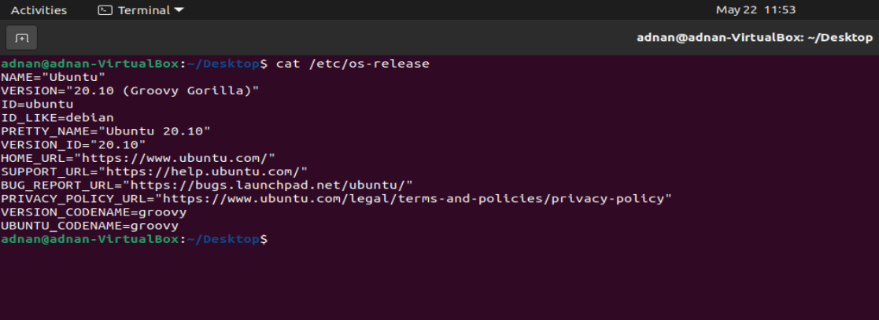

**More functionality of ls:**

**ls –l** will give directories and files name with their details (The file type, The file permissions, Number of hard links to the file, File owner, File group, File size, Date and Time, File name) and ls –al use to list hidden files and folders.

**ls –p** to check content inside directory, **ls –r** to list files and folders in reverse alphabetical order, **ls –s** to get the size of each file and folder with total size. We can combine above command as **ls –psr** or **ls –p –s –r** (sequence can be change) :

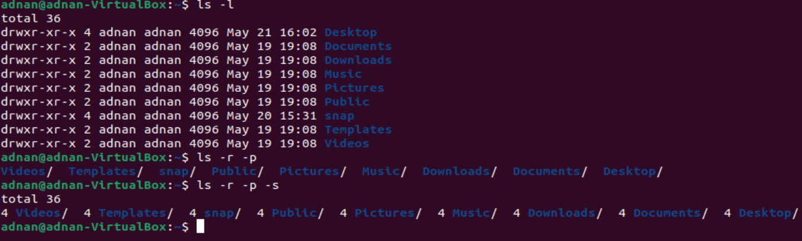

**cp command:**

Copying file sample.txt from current directory to Desktop using **cp** and checking content using **cat** after copying:

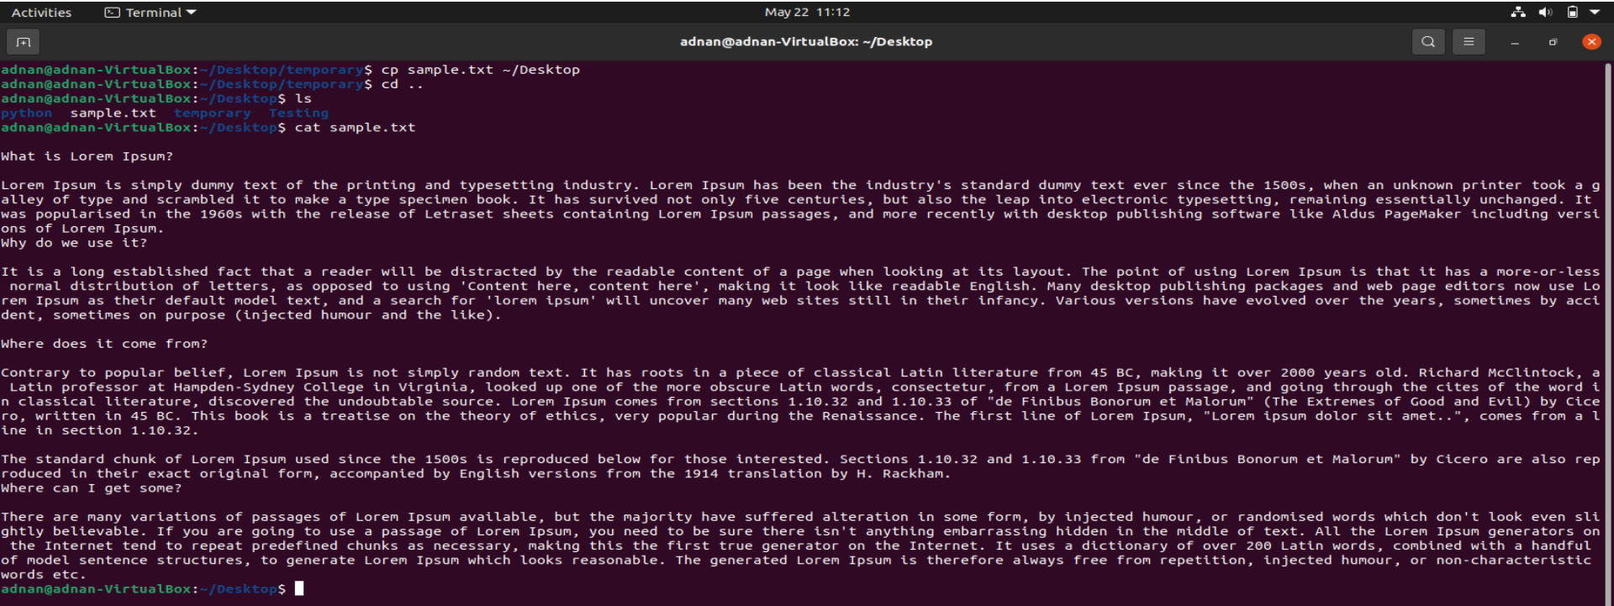

**mv command:**

Moving file1.txt, file2.txt and file3.txt from Desktop to temporary folder using **mv**:

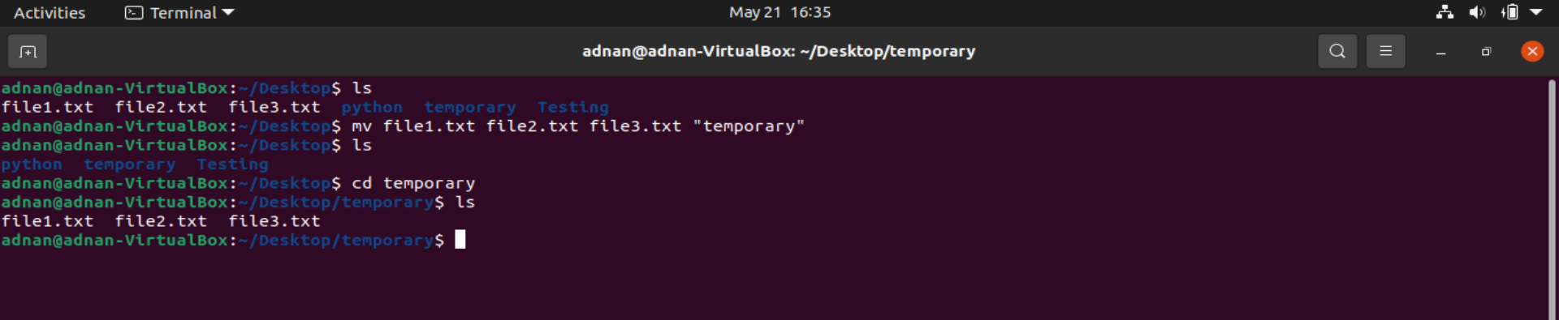

Renaming file3.txt to merged.txt using **mv**:

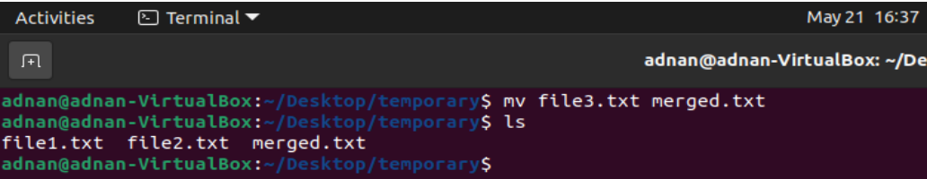

**history command:**

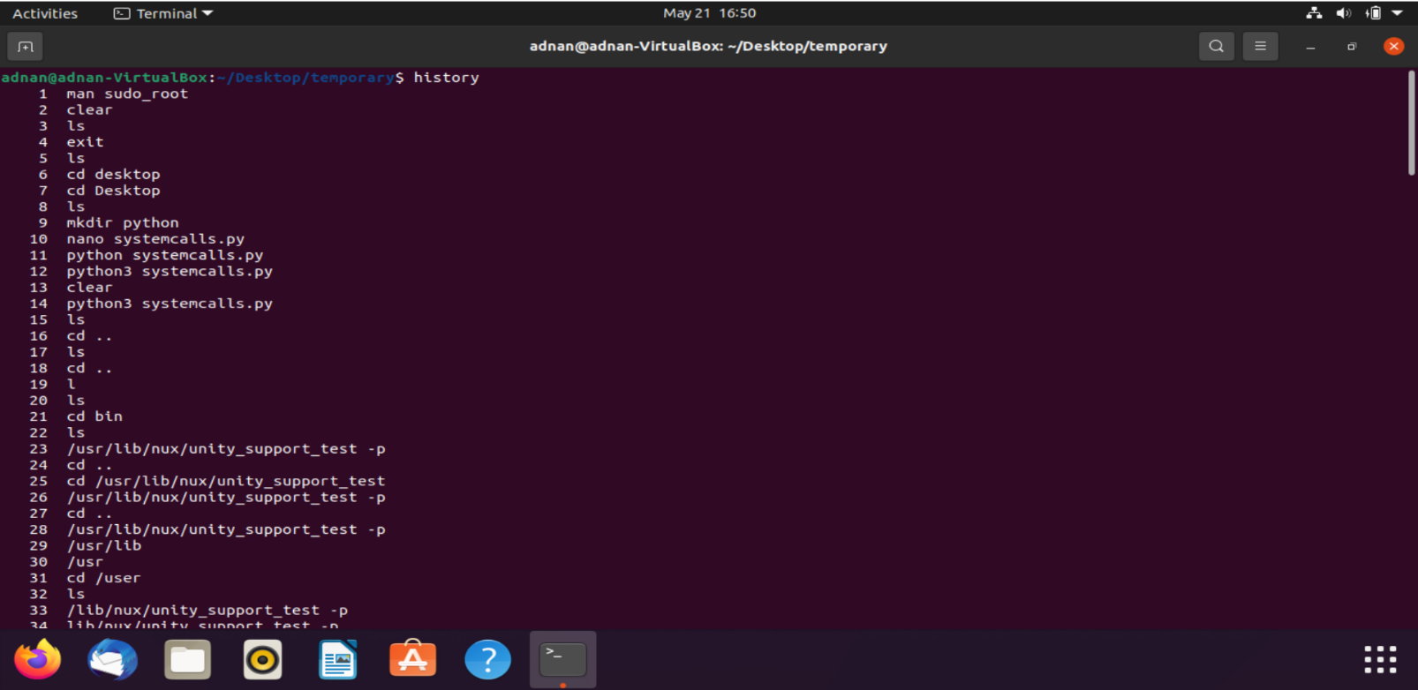

**grep command:**

**grep –n** “string” sample.txt return appearance of words with line no

**grep –I** used for removing case sensitivity

**grep –e** use for defining string expression multiple expression can be use using **–e** option

Output of combine of above options with **grep** command is given below:

String match is highlighted in red color

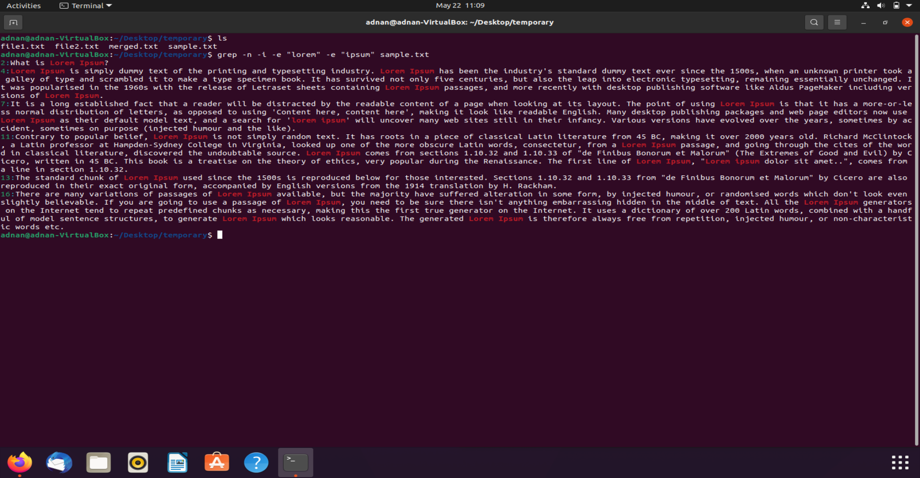

**ps command:**

getting process id, parent id their path, memory usage and CPU usage and sorting them in descending order using **ps** with options **–e –o** :

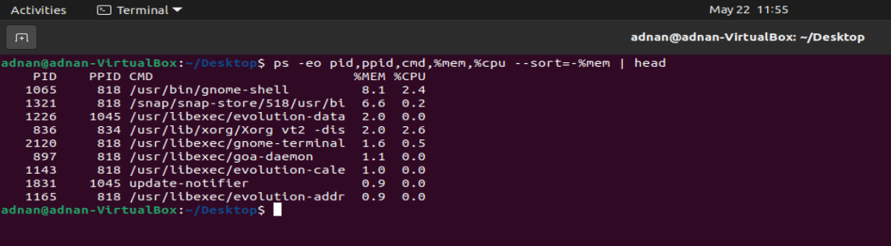

**free and lshw command:**

**free** use return information about memory state **--human** option will format output in human readable format.

**lshw** list hardware information **–short** option is used to get information in brief.

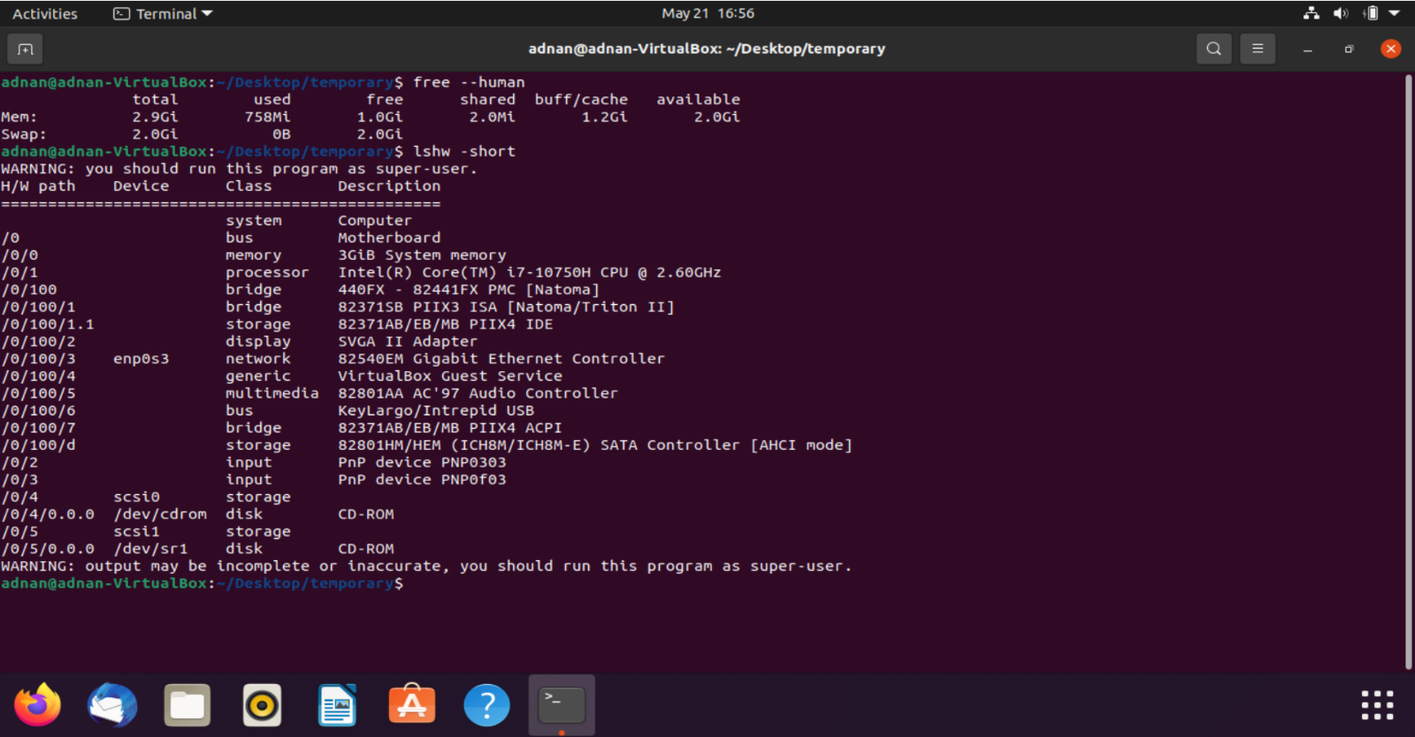

**hostname command:**

return hostname of system:



**sudo and apt command:**

sudo use for super user, apt list return applications present in a system

--upgradeable option use to check if any application needed an update, apt install will install specified application to system from host. (snap can be use instead of apt to install application). :

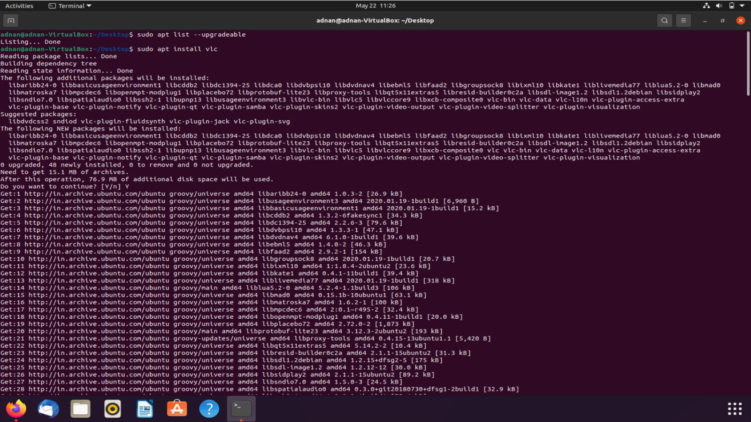

**ping command:**

